**Business Question and Visualization Report**

|  |  |
| --- | --- |
| Date | 24 July 2024 |
| Team ID | - |
| Project Name | Global Food Production Trends and Analysis |
| Maximum Marks | 5 Marks |

**Business Questions and Visualisation**

1. **What is the total global production of rice from 1961 to 2023?**

* *Visualization*: Card Visual
* Shows 269 billion tonnes of rice produced globally.
* *Screenshot of Visualisation*

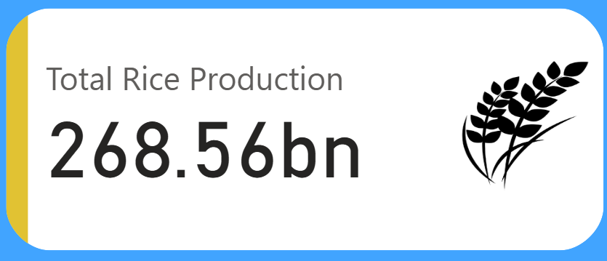

1. **How much wheat has been produced worldwide during the same period?**

* *Visualization*: Card Visual
* Highlights 282 billion tonnes total wheat production.
* *Screenshot of Visualisation*

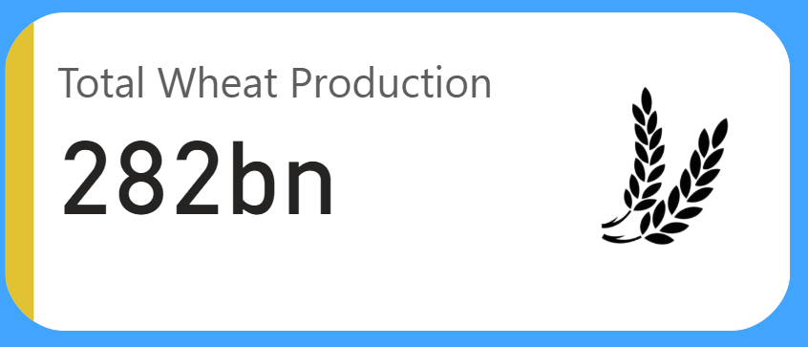

1. **What is the total production of tea globally?**

* *Visualization*: Gauge Chart
* Illustrates 2 billion tonnes of tea production.
* *Screenshot of Visualisation*

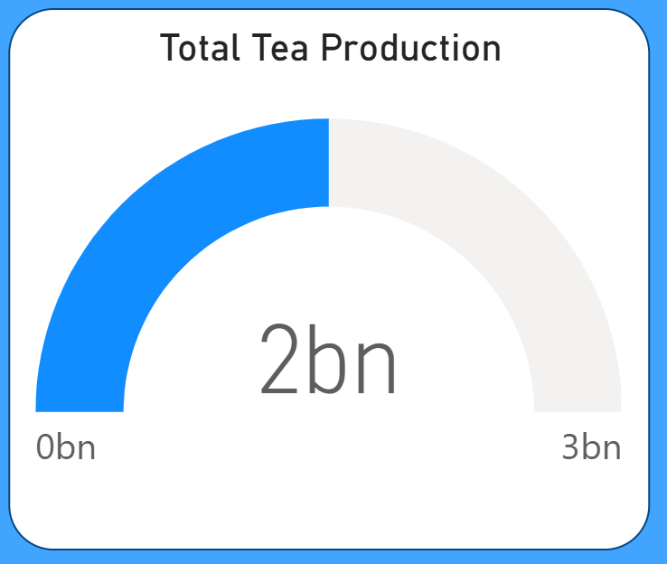

1. **Which regions have produced the most green coffee?**

* *Visualization*: Bar Chart
* Africa leads, followed by Asia and the Americas.
* *Screenshot of Visualisation*

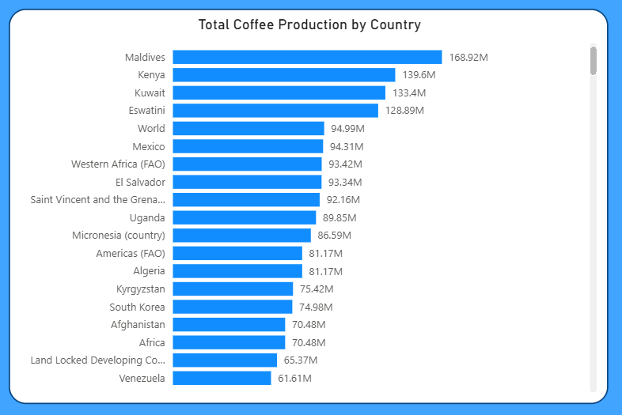

1. **How have wheat, maize, and rice production changed over time (1961–2023)?**

* *Visualization*: Area Chart
* Tracks trends and growth in key crop production.
* *Screenshot of Visualisation*

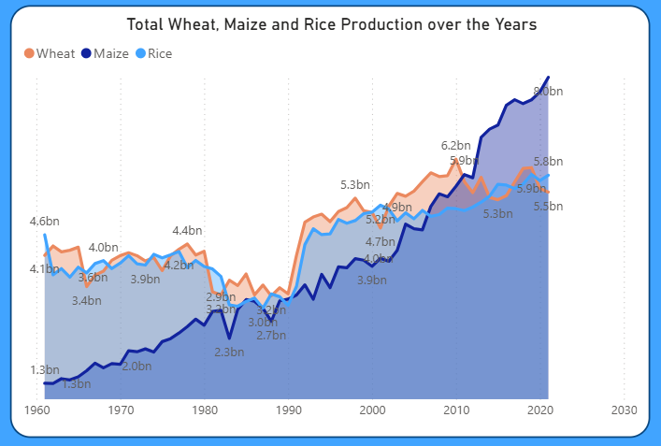

1. **What is the production breakdown of apples, avocados, bananas, and oranges by region?**

* *Visualization*: Stacked Bar Chart
* Shows regional contribution to major fruit crops.
* *Screenshot of Visualisation*

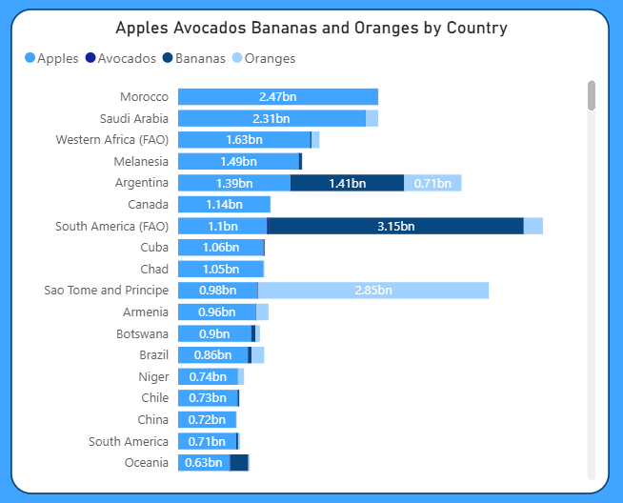

1. **How has Potato production evolved year by year?**

* *Visualization*: Donut Chart
* Yearly share and growth of Potato production.
* *Screenshot of Visualisation*

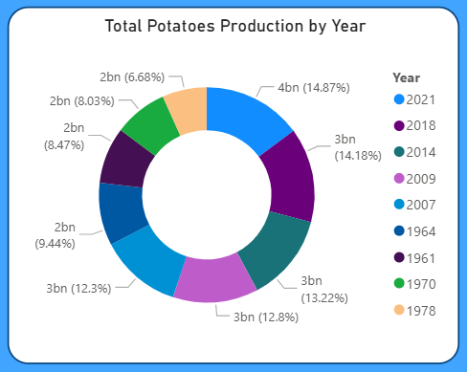

1. **What are the total production volumes of grapes, apples, bananas, and oranges?**

* *Visualization*: Stacked Column Chart
* Grapes lead at 43B tonnes, followed by apples, bananas, and oranges.
* *Screenshot of Visualisation*

